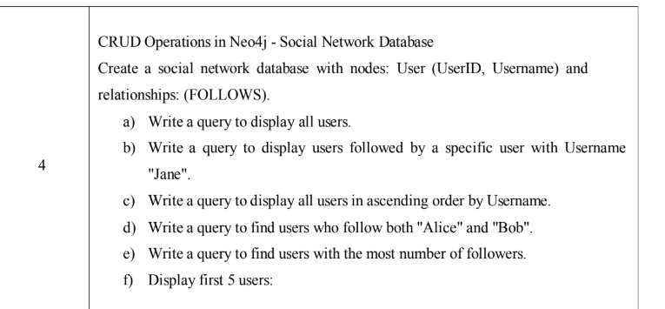

Social Network Database

CREATE
(u1:User {UserID:1, Username:"Alice"}),
(u2:User {UserID:2, Username:"Bob"}),
(u3:User {UserID:3, Username:"Jane"}),
(u4:User {UserID:4, Username:"Rohan"}),
(u5:User {UserID:5, Username:"Tanush"}),

(u3)-[:FOLLOWS]->(u1), // Jane → Alice
(u3)-[:FOLLOWS]->(u2), // Jane → Bob
(u4)-[:FOLLOWS]->(u1), // Rohan → Alice
(u5)-[:FOLLOWS]->(u1), // Tanush → Alice
(u4)-[:FOLLOWS]->(u2); // Rohan → Bob

- Display all users
MATCH (u:User)
RETURN u;
- Users followed by "Jane"
MATCH (j:User {Username:"Jane"})-[:FOLLOWS]->(u)
RETURN u;
- Users in ascending order

MATCH (u:User)

RETURN u

ORDER BY u.Username ASC;

MATCH → WHERE → RETURN → ORDER BY → LIMIT

- Users who follow BOTH Alice and Bob

MATCH (u)-[:FOLLOWS]->(:User {Username:"Alice"}),

(u)-[:FOLLOWS]->(:User {Username:"Bob"})

RETURN u;

- Users with MOST followers

MATCH (u:User)<-[:FOLLOWS]-(f)

RETURN u, COUNT(f) AS followers

ORDER BY followers DESC

LIMIT 1;

- First 5 users

MATCH (u:User)

RETURN u

LIMIT 5;

Additional

- Add new field age =16 for User "Alice"
- Update existing field User "Alice" to "Alicia"
- Add multiple fields for User "Bob" (age = 22, city = "Bangalore")
- Delete Node ( User: Tanush)
- Delete relationship between Rohan and Bob
- REMOVE property city field from Kiran

